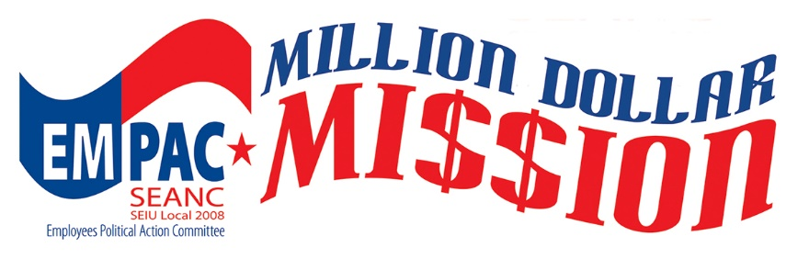
What is EMPAC? Simply put, the Employees Political Action Committee is the political arm of SEANC. SEANC’s primary role is to advocate for member priorities in the General Assembly. EMPAC’s primary role is to support the legislators and other politicians running for political office who are supportive of SEANC’s priorities.
In February, EMPAC launched a plan to fulfill EMPAC’s Million Dollar Mission. The goal is to recruit enough EMPAC Investors, SEANC members who make monthly contributions to EMPAC through payroll / pension deductions or bank draft, to raise $1 Million dollars for every two-year election cycle.
Why should you contribute to EMPAC? As a state employee, your job is political. Fair or not, your pay, benefits and way of life depend on politicians. If you are a retiree, your pension and health care depend on politicians. One way in which you can improve your future is to become politically active and invest in EMPAC.
When you contribute to EMPAC, you can help elect supportive public officials. With a more employee-friendly legislature, we are more likely to achieve the goals that matter to you: pay, health care and retirement.
In 2020, NC Free, a non-partisan political think tank, rated EMPAC as the second largest political action committee in North Carolina. EMPAC’s strong reputation for true bipartisan endorsements and commitment to our issues led to EMPAC topping the 2018 list of Longleaf Politics “16 endorsements that matter in NC politics.”
So, what’s in it for you? Besides helping EMPAC elect supportive candidates, you could be a winner. If you are a new investor and become an EMPAC Investor at the Bronze ($5/month) level or higher, you will be entered into a drawing for one of three gift cards - $500, $250 and $150. If you are already an EMPAC Investor and increase your contribution by at least $5.00, you will be entered into a separate drawing for one of three gift cards. Each new investor will also receive an EMPAC Investor Lapel Pin based on their contribution.
